Free yoga
join The yogi collective
May 14, 2014
10-11am

Wheeler Park
corner of birch and humphreys

Come enjoy the sunshine and some free yoga! This class will be ongoing and will benefit The Flagstaff Eco Ranch, a nonprofit organization that addresses global challenges via local actions by nurturing community, democracy, and practical sustainability through empowering education.
Please support The Flagstaff Eco Ranch’s efforts in promoting sustainability by bringing a small donation OR any of the following items:
- food scraps, compost, chicken feed, wood, or food items to feed volunteers
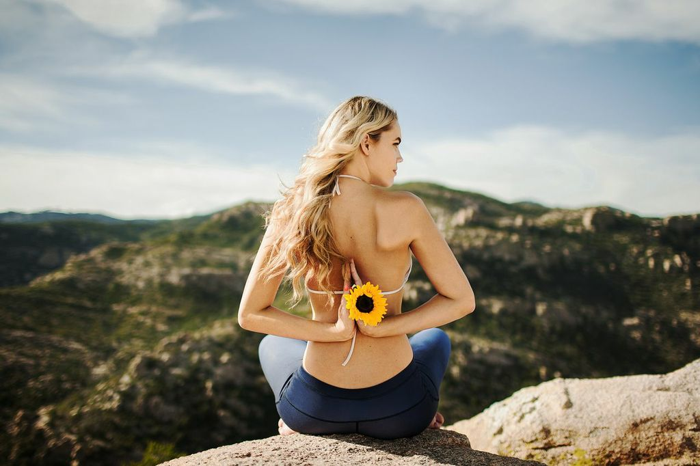
for more information contact: Katie @ 520.245.9002

