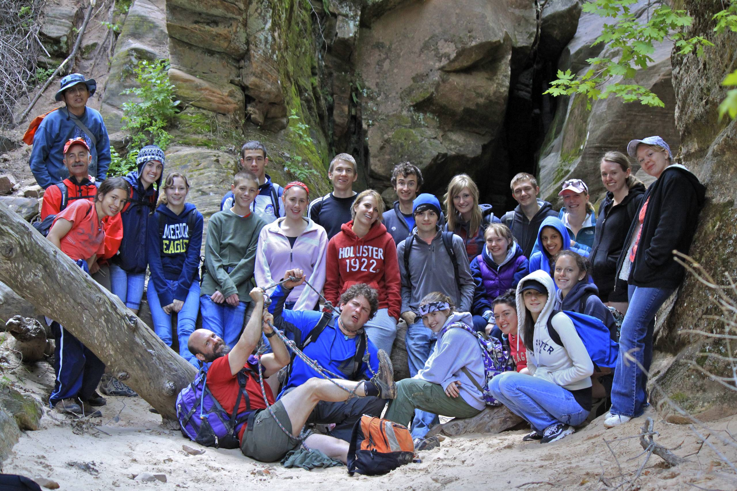
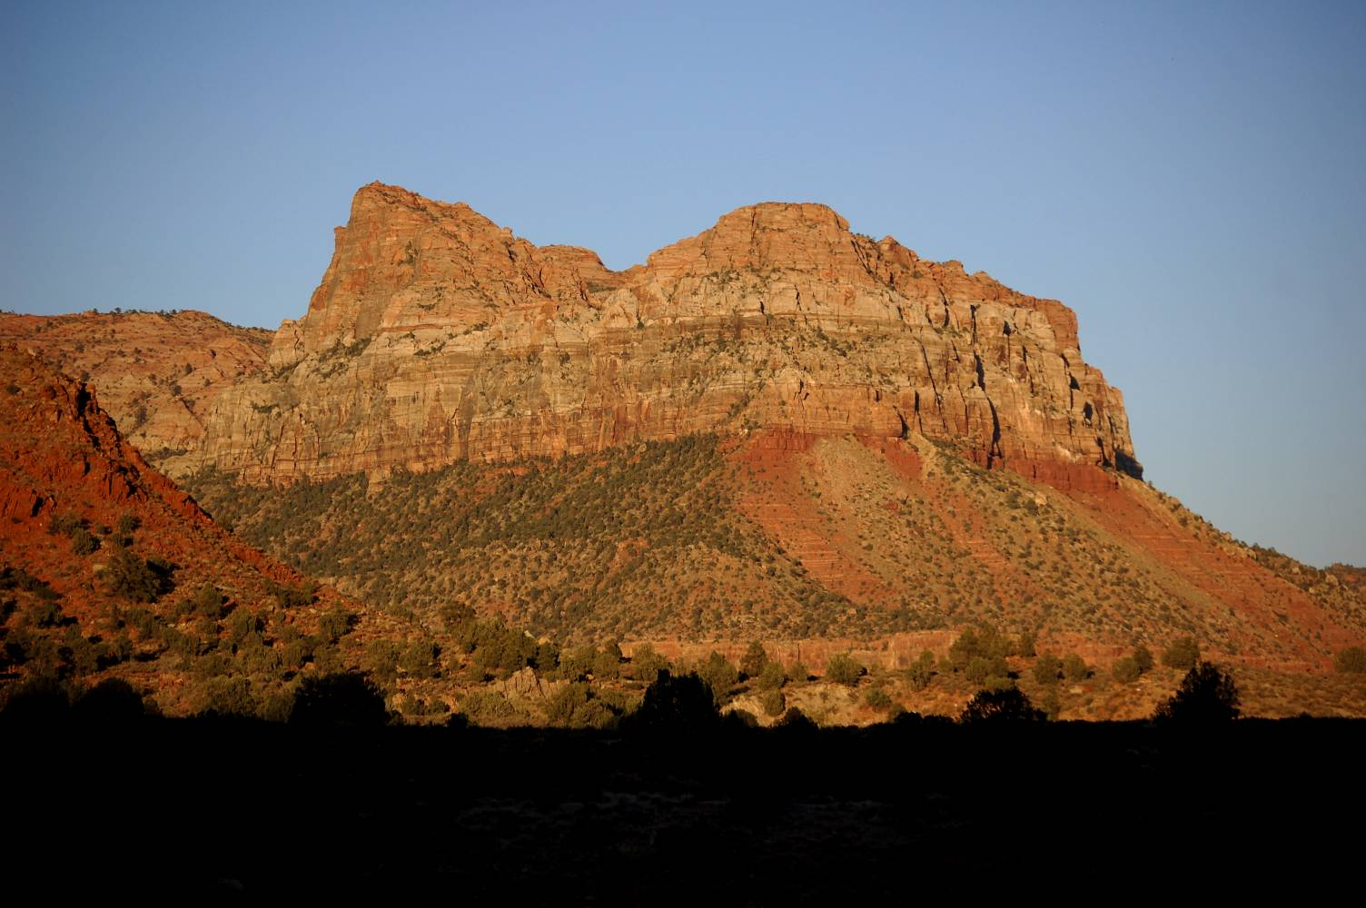
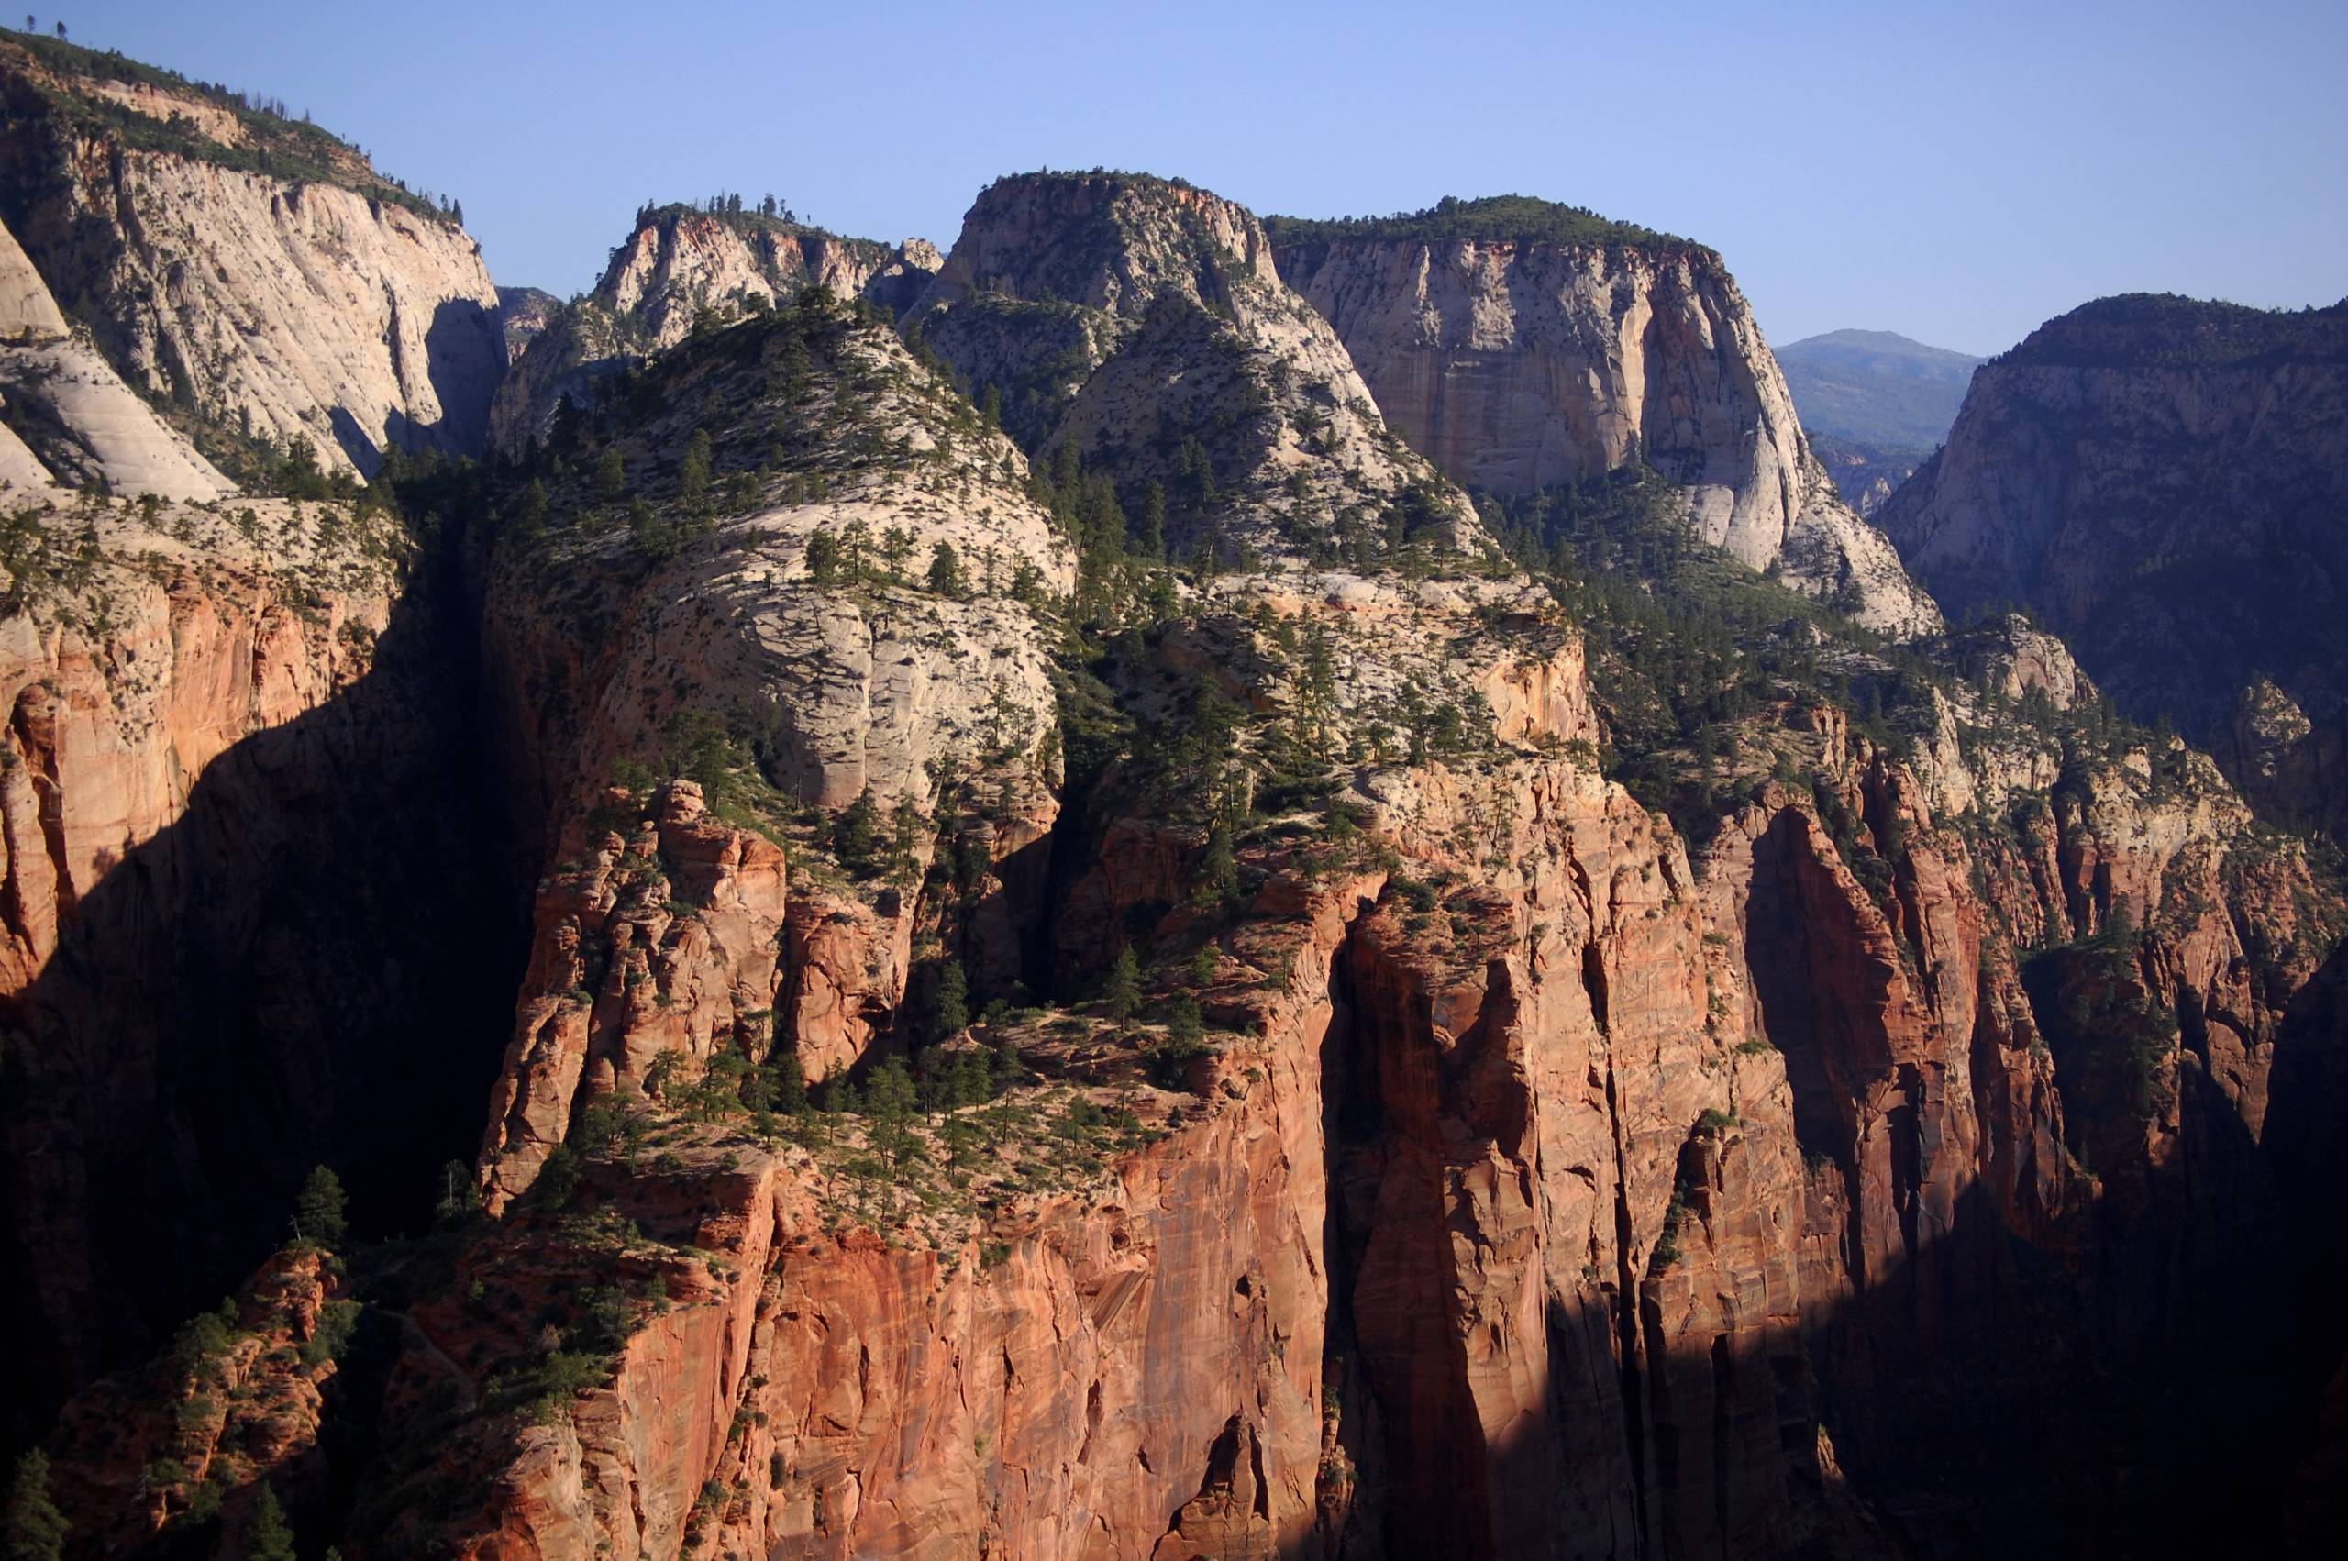
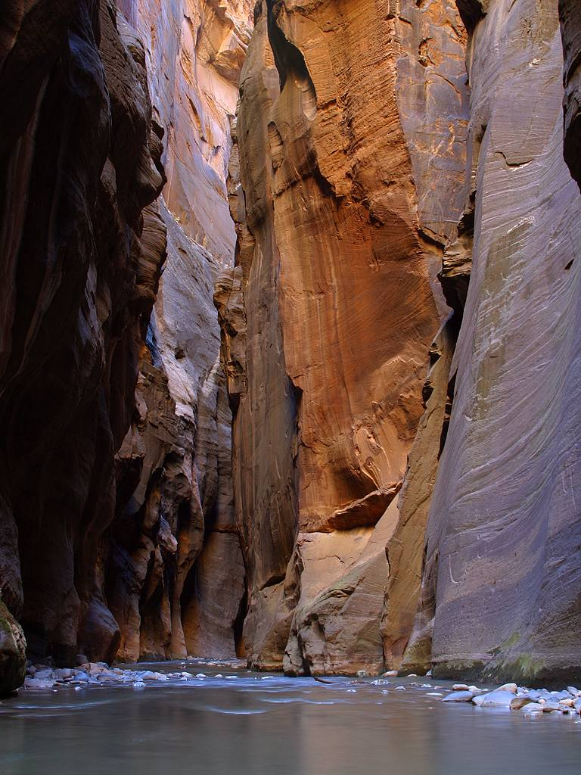
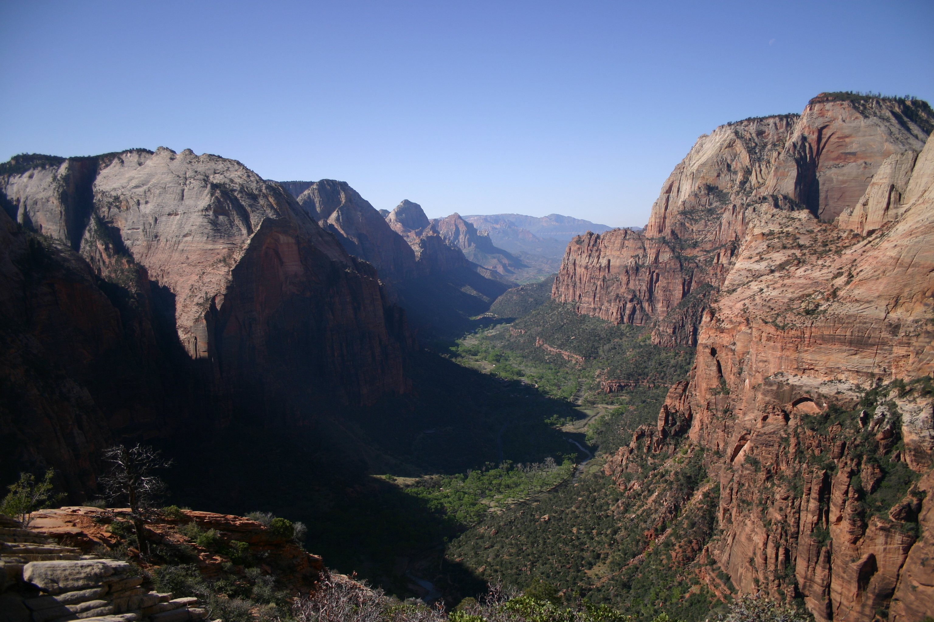
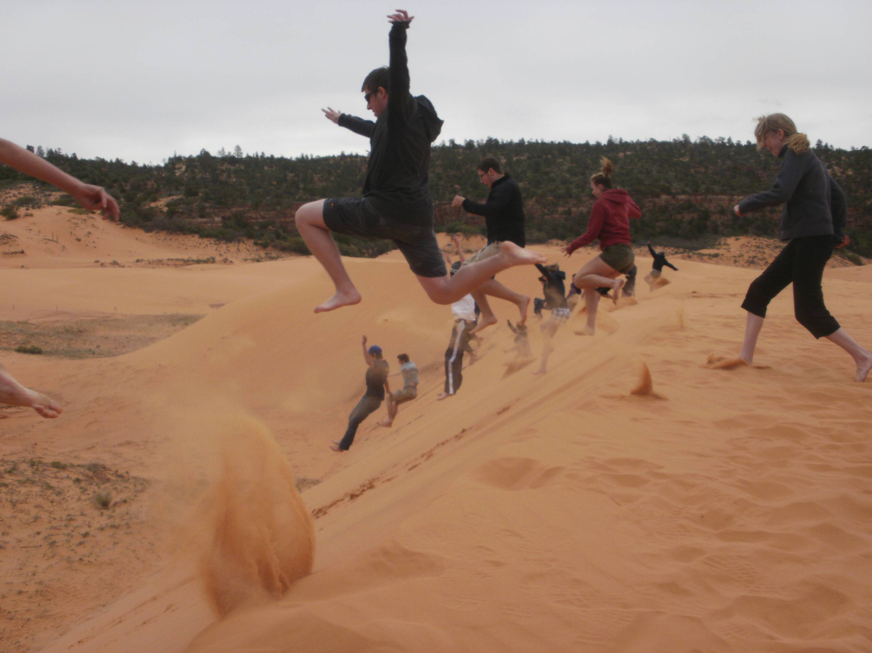

Contact Info
Aaron Tabor – Instructor
Aaron.Tabor@nau.edu
Jeff Meilander – Instructor
Jeffrey.Meilander@nau.edu

Course Description
This course is an interdisciplinary, experiential opportunity designed for students seeking exciting new ways to learn and engage with the NAU curriculum. Students will engage with biology, environmental science, politics, sustainability, and history while exploring Zion National Park. This hybrid course will run from May 9th to May 30th with in person meeting from Friday evening May 16th until Wednesday afternoon May 21st.

Course Goals
- Apply theories & curriculum normally learned in a classroom directly to the environment and culture
- Be immersed in the beautiful southwest
- Learn from and teach peers

Course Info
Date: May 12 to 30, 2014
Course Fee: $175 covers camping, travel, park fees
Instructors: Aaron Tabor and Jeff Meilander

National Park Field Biology – BIO 571

ZION

National Park Field Biology

BIO 571
Course Info
Date: Hybrid - May 12 to 30, 2014
In person – May 16 to 21, 2014
Course Fee: $175 – camping, fees, travel
Instructors: Aaron Tabor and Jeff Meilander
Course Description
An interdisciplinary, experiential opportunity designed for students seeking exciting new ways to learn and engage with biology, environmental science, politics, sustainability, and history while exploring Zion National Park.
Contact Info
Aaron Tabor – Instructor
Aaron.Tabor@nau.edu
Jeff Meilander – Instructor
Jeffrey.Meilander@nau.edu

ZION

National Park Field Biology

BIO 571
Course Info
Date: Hybrid - May 12 to 30, 2014
In person – May 16 to 21, 2014
Course Fee: $175 – camping, fees, travel
Instructors: Aaron Tabor and Jeff Meilander
Course Description
An interdisciplinary, experiential opportunity designed for students seeking exciting new ways to learn and engage with biology, environmental science, politics, sustainability, and history while exploring Zion National Park.
Contact Info
Aaron Tabor – Instructor
Aaron.Tabor@nau.edu
Jeff Meilander – Instructor
Jeffrey.Meilander@nau.edu

ZION
Course Info
Date: Hybrid - May 12 to 30, 2014
In person – May 16 to 21, 2014
Course Fee: $175 – camping, fees, travel
Instructors: Aaron Tabor and Jeff Meilander
Course Description
An interdisciplinary, experiential opportunity designed for students seeking exciting new ways to learn and engage with biology, environmental science, politics, sustainability, and history while exploring Zion National Park.
Contact Info
Aaron Tabor – Instructor
Aaron.Tabor@nau.edu
Jeff Meilander – Instructor
Jeffrey.Meilander@nau.edu

Course Info
Date: Hybrid - May 12 to 30, 2014
In person – May 16 to 21, 2014
Course Fee: $175 – camping, fees, travel
Instructors: Aaron Tabor and Jeff Meilander
Course Description
An interdisciplinary, experiential opportunity designed for students seeking exciting new ways to learn and engage with biology, environmental science, politics, sustainability, and history while exploring Zion National Park.
Contact Info
Aaron Tabor – Instructor
Aaron.Tabor@nau.edu
Jeff Meilander – Instructor
Jeffrey.Meilander@nau.edu

National Park Field Biology

BIO 571

ZION

ZION

National Park Field Biology

BIO 571
Course Info
Date: Dec. 14, 2014 to Jan. 4, 2015
Eligibility: 2.5 GPA
Cost: Includes national flight in Chile, travel, food, lodging, fees, NAU tuition (3 credits), camp gear, evacuation and int’l medical insurance. $3919
Instructor: Jeff Meilander
Info Session
Info Session – Jan
Jeffrey.Meilander@nau.edu

